Undergraduate Research Internship (URI)
2023-2024 Academic Year

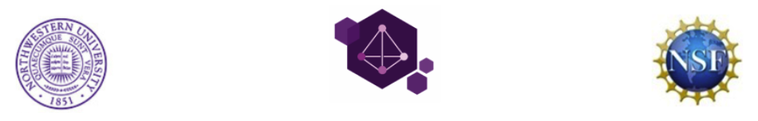
Northwestern University
Materials Research Science & Engineering Center (NU-MRSEC)

Application Deadline: October 31, 2023

First Name: MI: | Last Name:
Gender: □ Male □ Female
Present College/University: | Major Field(s) of Study:
Current Academic Year:  □ 1 □ 2 □ 3 □ 4 | Expected Graduation Date:
Overall GPA/Scale:
Current Mailing Address:  Street:  City:  State:  Zip:  Current Phone:  Current E-mail: | Permanent Mailing Address:  Street:  City:  State:  Zip:  Permanent Phone:  Other E-mail:
Citizenship (Must be a U.S. citizen or permanent resident):  □ U.S. Citizen □ Permanent Resident | Date of Birth:  Place of Birth:
Ethnicity:  □ American-Indian □ Asian  □ Black/African-American □ Hispanic  □ Mexican-American □ Native Pacific Islander □ Puerto Rican □ White/Caucasian  □ Multiracial/Other __________ | Previous Colleges/Universities Attended:  (Please list all):  Have you participated in a research program in the past? (Please indicate all programs.)  □ No □ Yes,  When:  Where:

Required Supporting Documents

Transcript: Unofficial transcripts will be accepted for the application; official transcripts will be required should you be offered an internship.

Two References: Provide two letters from sources who can account for your academic and research abilities,
experience and potential.

 | Name | Title/Organization | E-mail Address | Telephone | Mailing Address
Ref. #1
Ref. #2

Statement of Goals: Describe your academic and research goals and how your participation in this program
would help you achieve these goals. (Approximately 200-250 words)

List any societies, fraternities, organizations, etc. you have been involved with during college:
________________________________________________________________________________________
________________________________________________________________________________________

List any relevant work or laboratory experience (include employer, job title or type, dates of employment, and previous participation in any research programs):

Employer | Job Title | Dates of Employment | Research? Y or N

Research Interests: (please check all that apply)

Chemistry | Chemical Engineering | Materials Science | Physics
□ Organic Synthesis | □ Polymer Chemistry | □ Metals | □ Experimental Condensed Matter
□ Inorganic Synthesis | □ Polymer Physics | □ Biomaterials | □ Theoretical Condensed Matter
□ Spectroscopy | □ Catalysis | □ Electronic Materials | □ Lasers
□ Polymer Chemistry | □ Biochemical Engineering | □ Ceramics | □ Computational
□ Biochemistry | □ Biomaterials | □ Polymers
□ Catalysis | □ Modeling and Simulation | □ Computational
□ Theory | □ Nanotechnology
□ Other | □ Other | □ Other | □ Other

How did you hear about this program?
Please specify:__________________________________________________

Are you eligible for work-study positions (this will not impact your selection for the award, but is helpful to us in processing the award)? Yes / No
Please email the following materials to mrc@northwestern.edu
1. Completed Application
2. Statement of Goals
Questions? 3. Two Letters of Recommendation
847-491-3606 4. Unofficial Transcript

Agreement: By submitting this application, I attest that I meet the program requirements listed on this application and that I have disclosed all of the information this form is requesting of me. If accepted to this program, I agree to submit the program evaluation and a final report, which summarizes my research activities, by the final day of the NU-MRSEC URI program. In submitting this application, I understand that failure to disclose any requested information and/or failure to comply with the above terms and conditions may result in disqualification of and/or termination from the NU-MRSEC URI program.
It is the policy of Northwestern University not to discriminate against any individual on the basis of race, color, religion, national origin, sex, sexual orientation, marital status, age, disability, or veteran status in matters of admission, employment, housing, or services or in the educational programs or activities it operates, in accordance with civil rights legislation and University commitment.

